PROJECT REPORT
On
Real-Time Face Mask Detector Using Python, OpenCV, Keras
(CST SPL-1 Semester 3rd Mini Project)

Submitted to: Submitted By:
Mr. Hemant Singh Pokhariya Mr. Aaviral Bajpai
(CC-CST SPL 1, SEM :- 3) Roll No.:2017443
Guided BY: CST SPL 1-3rd Sem
Dr. Vishen Gupta Session – 2021-2022
(Resource Person)

DEPARTMENT OF COMPUTER SCIENCE AND INFORMATION TECHNOLOGY
GRAPHIC ERA UNVERSITY, DEHRADUN



CERTIFICATE

This is to certify that the project report entitled “Face Mask Detection Using OpenCv Keras” is a bonfire project work carried out by Aaviral Bajpai, Roll No- 2017443. in partial fulfillment of award of degree of B- tech of Graphic Era Deemed University, Dehradun during the academic year 2021-2022. It is certified that all corrections/suggestions indicated for internal assessment have been incorporated. The project has been approved as it satisfies the academic requirements
associated with the degree mentioned.

Dr. Devesh Pratap Singh,
HOD ( Computer Science)

ABSTRACT
The project is Real Time Face Mask Detector which is written in Python programming language and CNN(Convolutional Neural Networks ) which are used to recognize a particular set of images which are present in our data sets . With which the prediction of images of people wearing mask or not is done.

Convolutional Neural Networks
CNN play’s a major role in completion of this project.
A Convolutional Neural Network (CNN) is a type of artificial neural network used in image recognition and processing that is specifically designed to process pixel data.

Programming Language Used
Python is the programming language used in this project. It is an interpreted, object-oriented, high level programming language with dynamic semantics. Python's simple, easy to learn syntax emphasizes readability and therefore reduces the cost of program maintenance. It very attractive for Rapid Application Development. The Python interpreter and the extensive standard library are available in source or binary form without charge for all major platforms, and can be freely distributed

Pre-requisite for the project
- Python
- Machine learning
- Deep learning
- TensorFlow
- Keras API
- Open-CV API

METHODOLY FOLLOWED

- Installation Of the Dependencies
Some dependencies are needed installed for successful compilation of the project.
To download this, we need to be familiar with the pip command in command prompt.
Which are:
- TensorFlow
- Keras
- OpenCV
- Numpy
- Matplolib
- Scipy

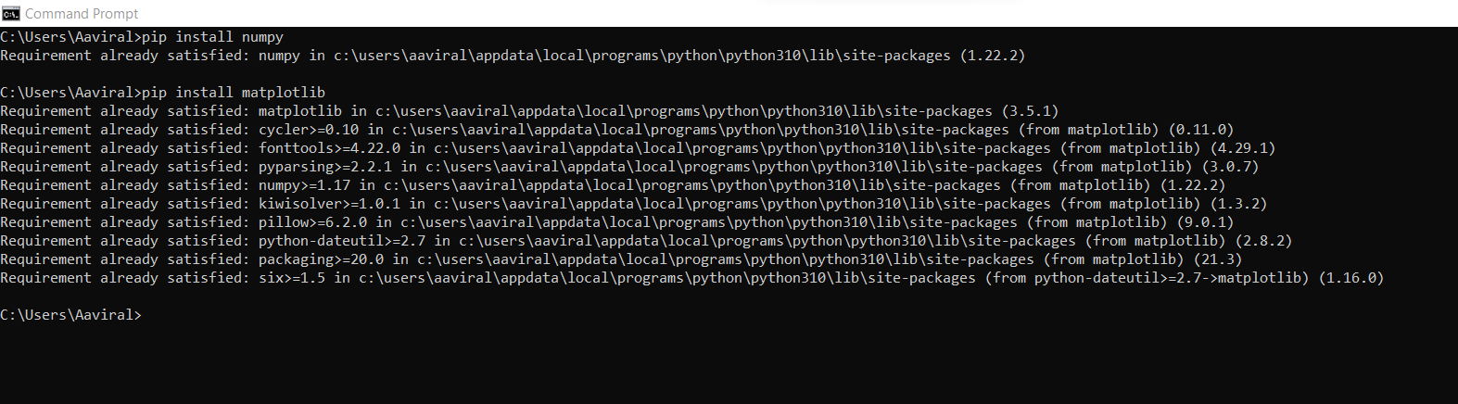

- Downloading Dataset
To create a working model for the project. We need to create a folder of dataset where we have to download a number of images of people wearing mask and without mask. This in the end finally helps in training our model.

- Data Preprocessing
To create and deploy the model we first need to preprocess the model, we will convert all the images in our data (i.e., with_mask or without _mask) into arrays so that we can traverse easily into each image. We have used two empty list data and labels, In data we are appending all the image arrays in the list and in labels we are appending all the corresponding images that are with_mask and
without_mask
Now we are traversing through all the images in the dataset using the listdir function. After that we are converting the images to array using img_to_array function. And then we are appending the images to the following lists. We are using labelbinarizer on the labels to convert them into numeric values by using one hot encoding method.
After this we will convert this data and labels into numpy arrays as the deep learning model only works with arrays by using np.array method.
Now we are using train_test_split method to split the training and testing data(trainX,testX,trainY,testY), we have given the test_Size 30% i.e., out of 1981 images we have given 30% to testing and remaining 70% used for training purpose.

- Training Of The Model

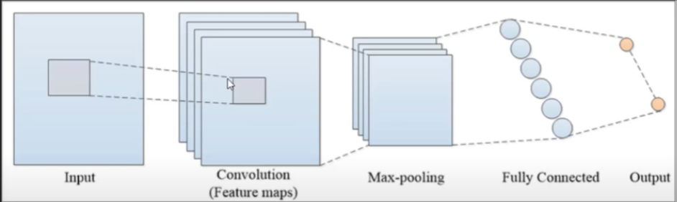

For training of the model we are using MobileNet API. It is much faster and uses less number of parameter for good assessment. With the help of mobilenetV2 we are creating here two models(Base model and a Head model). We have used the ImageDataGenerator which help in generating a lot of dataset as it joins many images into a single image.
We are creating an BaseModel object using mobilenetV2.
After that we are creating a HeadModel object in which we have passed the BaseModel output and than we are performing averagepooling , flatten, dense and dropout functions.
AveragePooling-Average pooling involves calculating the average for each patch of the feature map.
Dropout - The Dropout layer randomly sets input units to 0 with a frequency of rate at each step during training time.
Flatten - A flatten operation on a tensor reshapes the tensor to have the shape that is equal to the number of elements contained in tensor non including the batch dimension.
Dense - Dense Layer is simple layer of neurons in which each neuron receives input from all the neurons of previous layer, thus called as dense.
Now we are calling the model function which creates our actual model that we will train.
For compilation of the model we have given the initial learning rate to 1e-4 and we have used the adam optimizers which is a goto optimizers for image prediction methods.
With the help of fit function we are training the head of the model with all the help of data augmentation.
Now we are finally evaluate the network with model.predict method. And we are having the classification report with classification_report function.
Finally we are saving the model that we have get now into he “h5” format.
This is how we trained our final model.

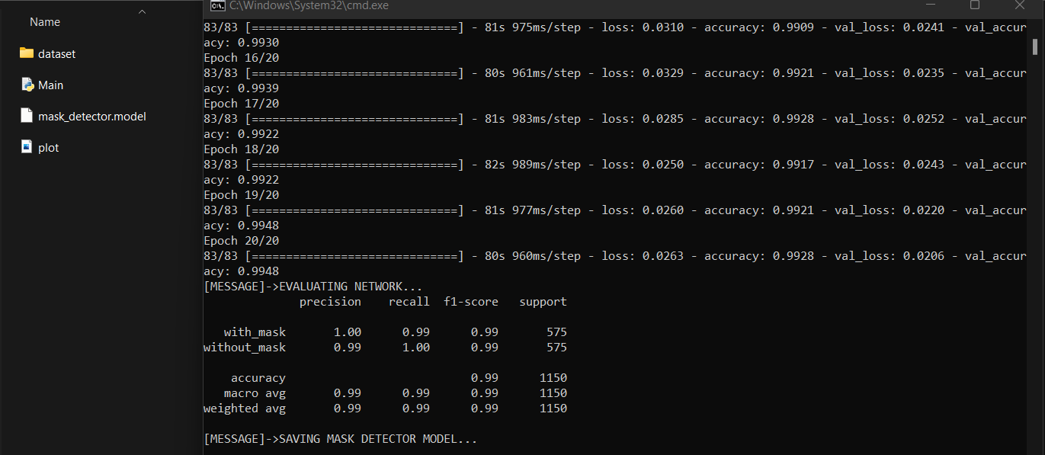

- FACE DETECTION MODEL

With the help of face detector file(prototxt and caffemodel)and deep learning mask detector model we will detect the face and camera operation with OpenCV.
We have created an object facenet in which we are using cv2.dnn.readnet method where we are giving the path of these two face detection files. And with the help of load_model we are opening our model created. And with VideoStream we are opening the camera. We are creating a frame(an image) for the video stream and giving it a width size 300.
Now we are defining a function detect_predict_mask where we are passing these parameters(facenet,masknet,frame)which return the location of the dimensions of face and prediction which predict the perentage of person wearing mask or not.
At last we gave the label and color to the frame whether the person is wearing mask or not. As cv2 follow BGR color coding if mask(0,255,0)and if not(0,0,255).

CONCLUSION

This project has really benefited me in understanding the convolution neural networks(CNNs) and how to use the most commonly used python APIs in deep learning model. Also by working on this project I am able to clear my concepts used in the most used project work in the covid-19 period.
APPENDIX

Code

REFERENCE

- https://en.wikipedia.org/wiki/Convolutional_neural_network
- https://pyimagesearch.com/2020/05/04/covid-19-face-mask-detector-with-opencv-keras-tensorflow-and-deep-learning/
- Geeksforgeeks
- https://keras.io/api/preprocessing/image/#imagedatagenerator-class
- https://www.geeksforgeeks.org/opencv-python-tutorial/

